**Ulayaw User Manual**

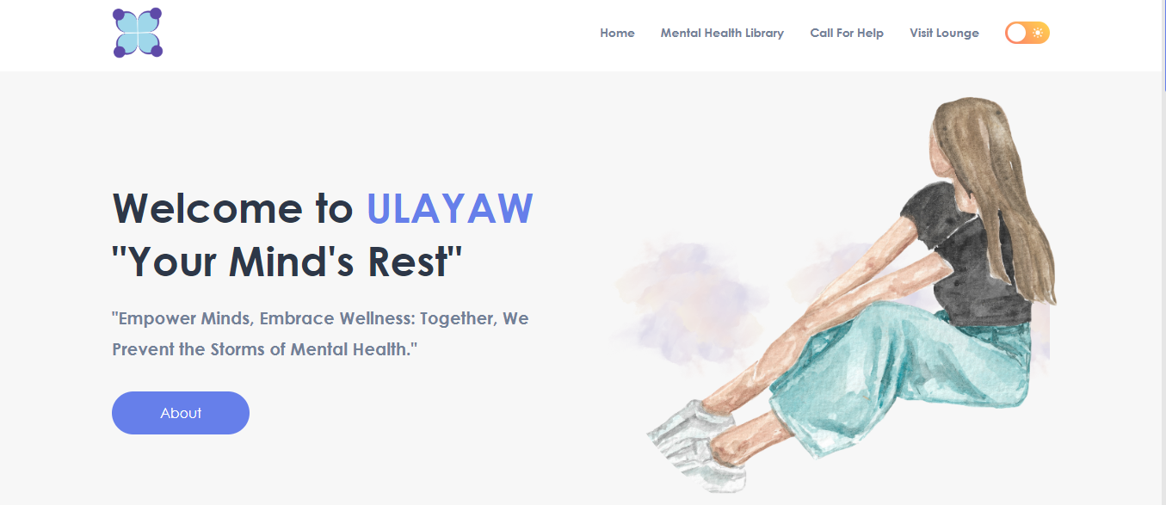

Link to website:

<https://ulayaw.pythonanywhere.com/>

Landing Page



The landing page consist of the links to the different features of the website. The navbar consist of these links which directs users to different pages:

1. Mental Health Library
2. Call For Help
3. Visit Lounge **(Clicking this will open a new tab)**

There is also a toggle for dark mode on the upper right of the navbar.

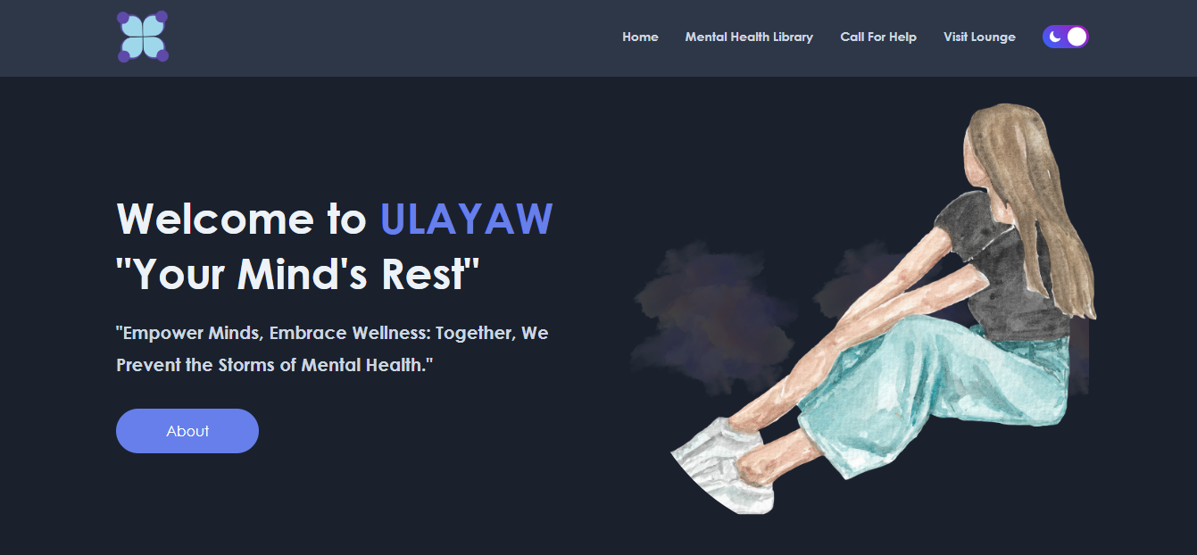

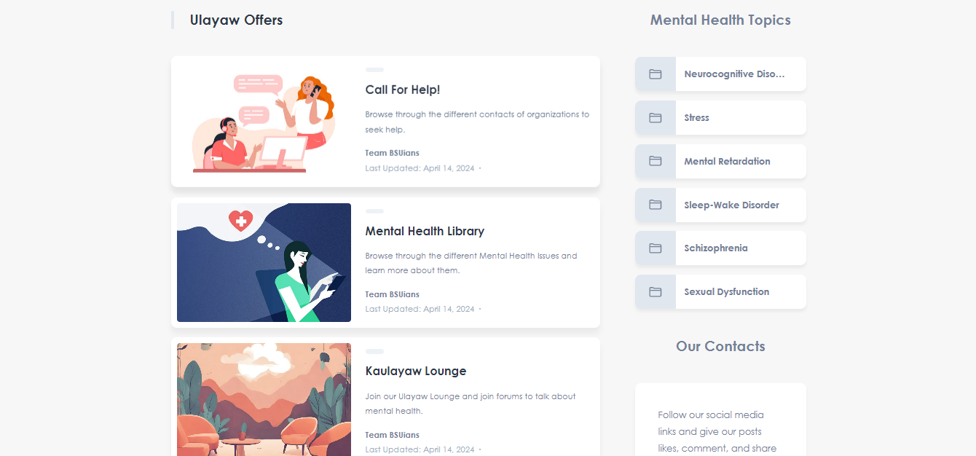

By scrolling further the landing page, on the left panel, you can see different cards containing information about the features, each of these are clickable and will redirect you to the certain pages.

Focus on the right side of the screenshot above, you can see the list of 6 different mental health disorders, which shows in random, each of these are clickable and will redirect you to a blog about a specific mental health, for example, let’s just say the Neurocognitive container is clicked it will redirect you to the view below:

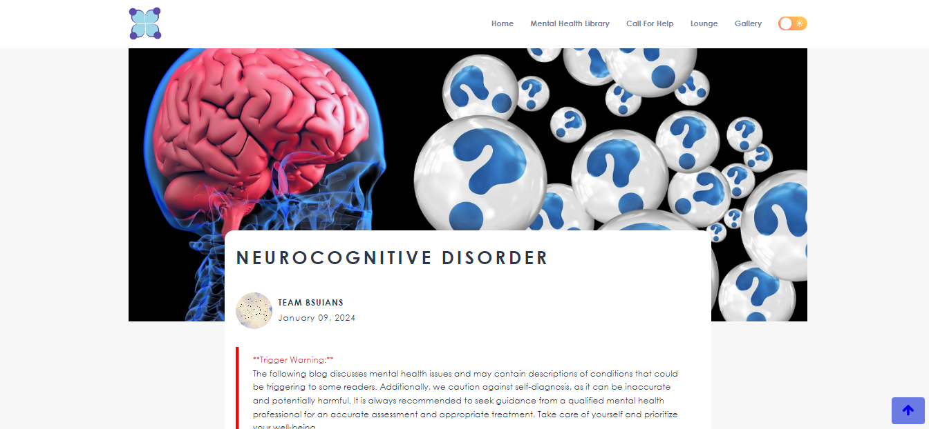

Mental Health Library



By clicking the “Mental Health Library” in the navbar, you will be redirected to another page.

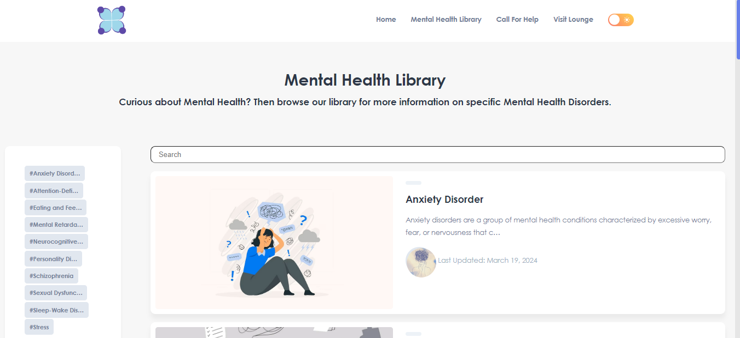

This page consist of a library of mental health disorders and information about specific mental health issues.

These containers are clickable and will redirect you to a blog page about the specific mental health disorder.

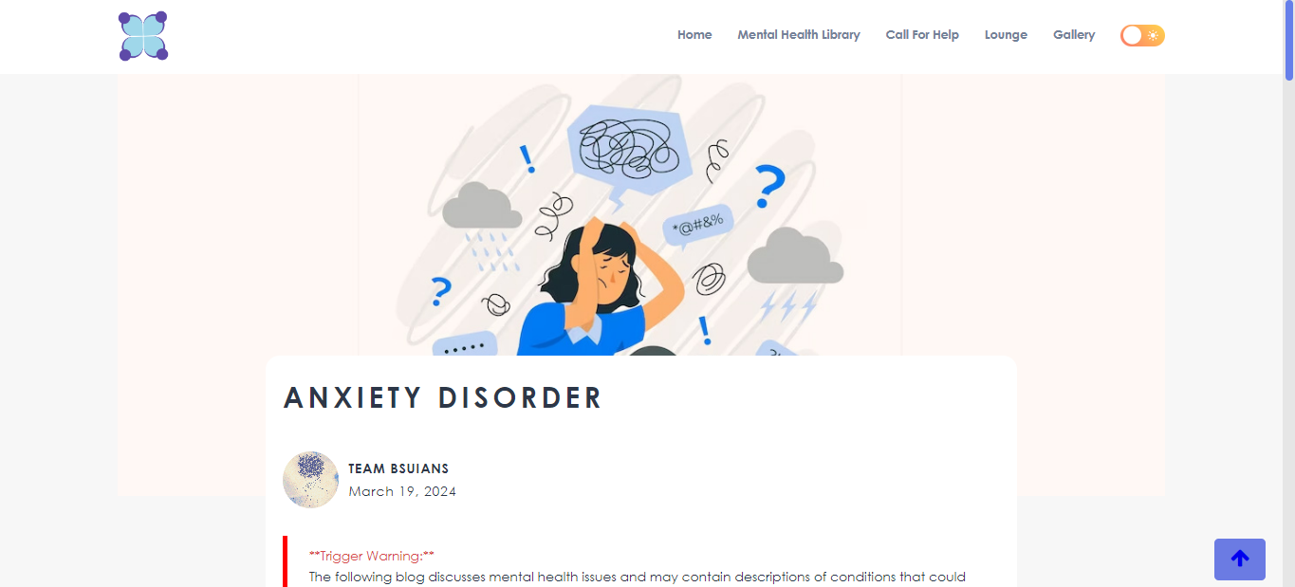

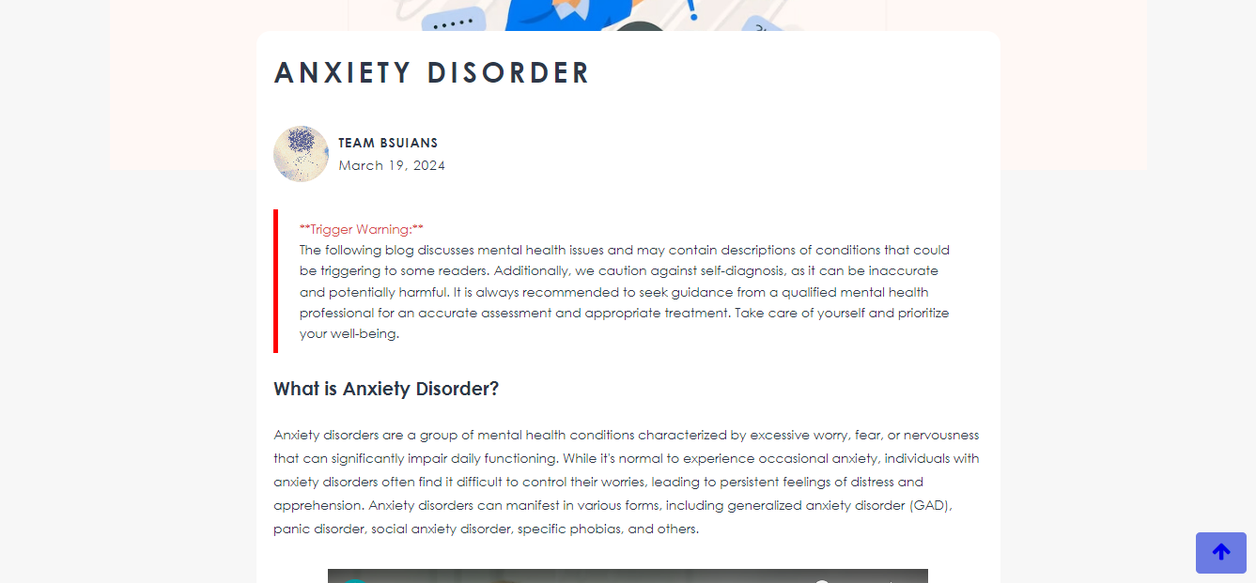

Each blogs have relevant information about the mental health disorder. User’s can read these information and at the end of the blog, they will see these containers:

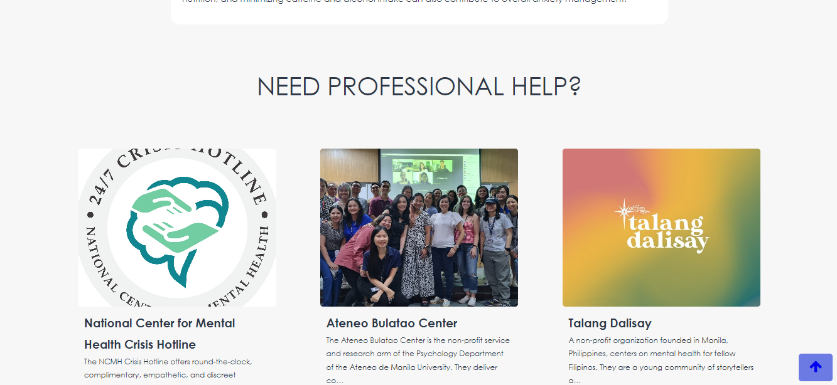

These containers are also clickable, and when clicked, will redirect them to another blogpage about organizations ready to help. More info on this on the next page, which is the Call For Help.

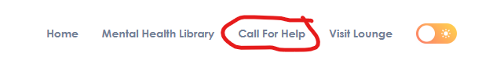Call For Help

This page is focused on introducing users the different mental health organizations here in the Philippines.

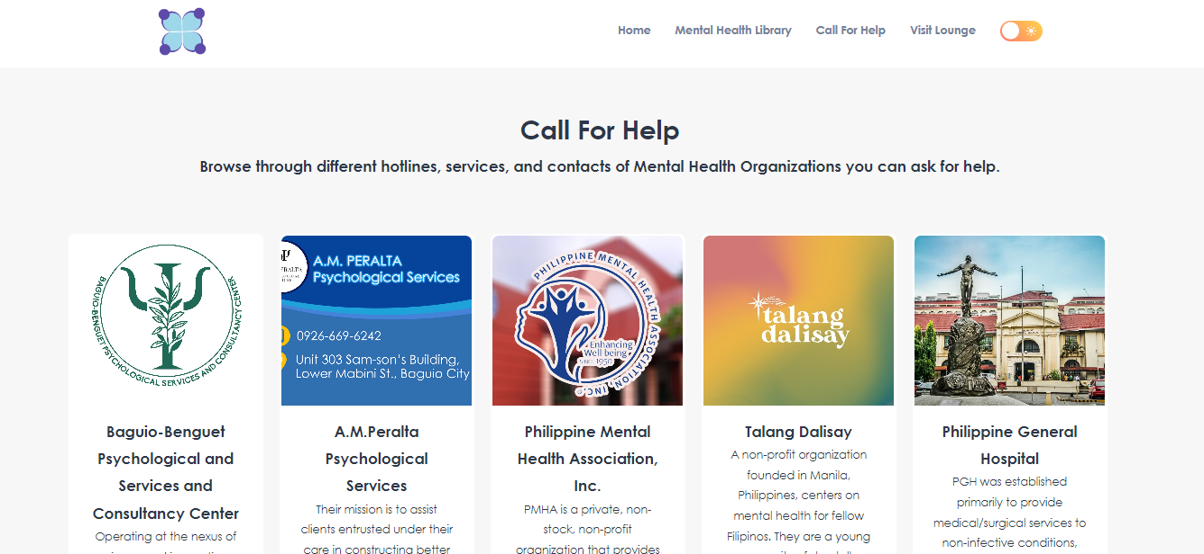Each of these cards is clickable, and when clicked, will redirect users to a blogpage about these organizations, containing short descriptions about them, and more importantly, their contact information.

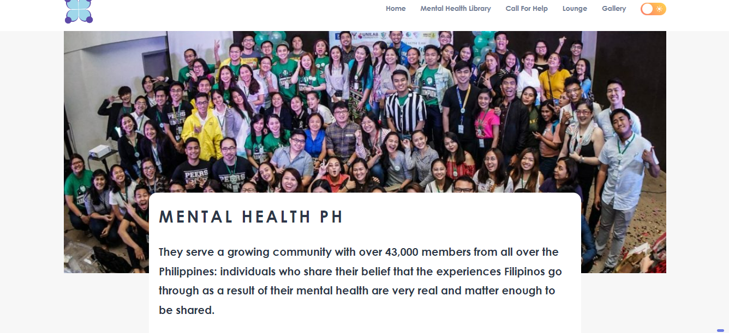

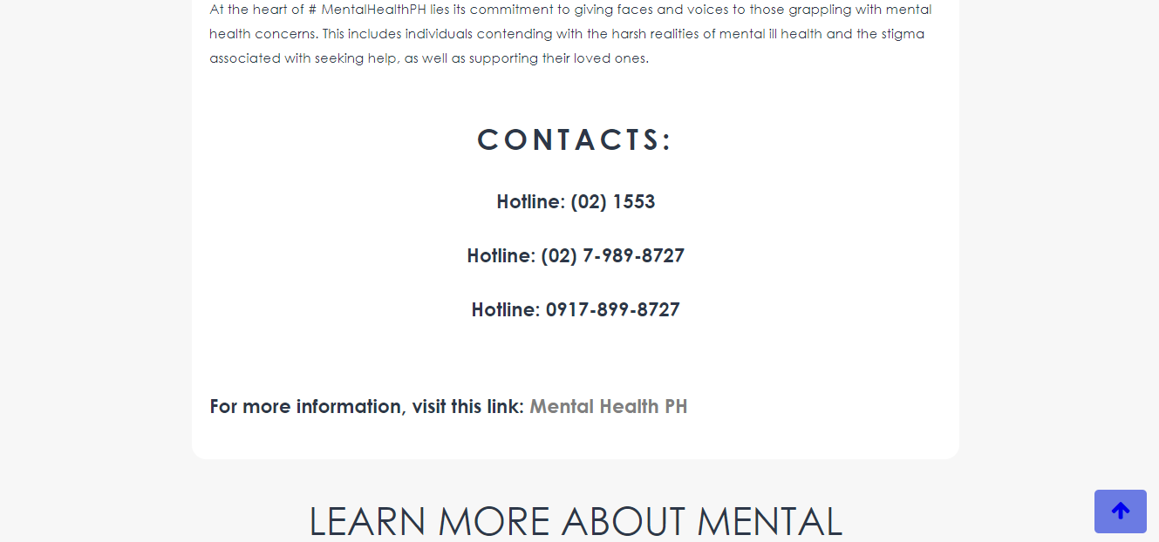

Each of these contacts are sourced from their websites, which you can also visit by clicking the link at the bottom part of the blogpage.

At the end of each organization blogs, users can also find panels about different mental health disorders form the mental health library:

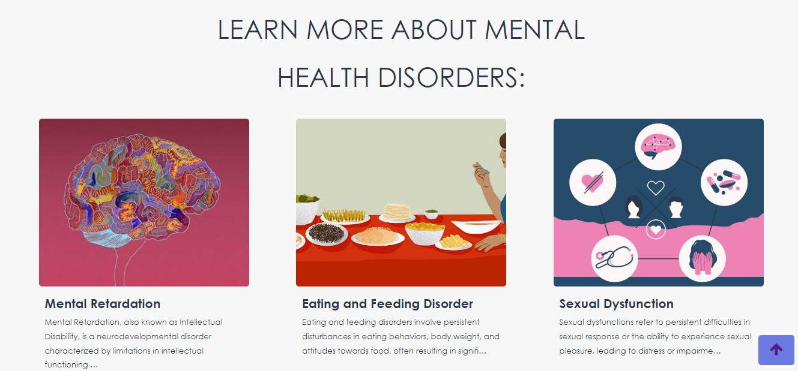

Call For Help Incident Report

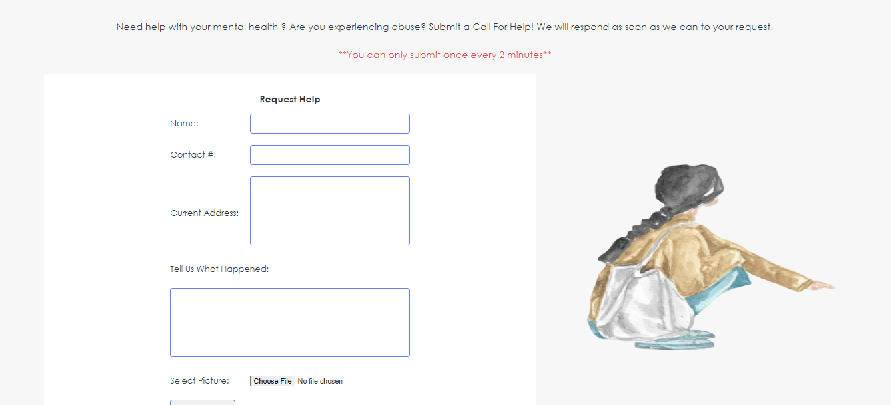

At the bottom-most part of the Call Help Page is a form intended for the purpose of requesting for help. This was inspired by an interview with a guidance counsellor, where she mentioned about abuse and the developers opted to try to create an incident report form. All information from this form will go to the administrator panel:

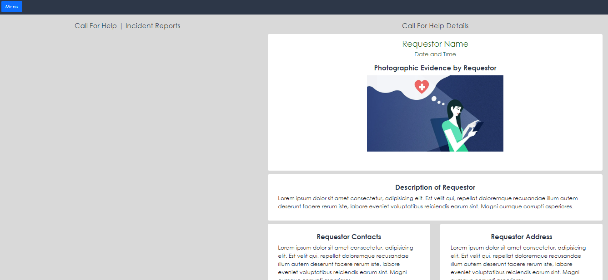

The admnistrator panel be discussed further in the **Administrator Login in Ulayaw Lounge** Section**.**

About Page

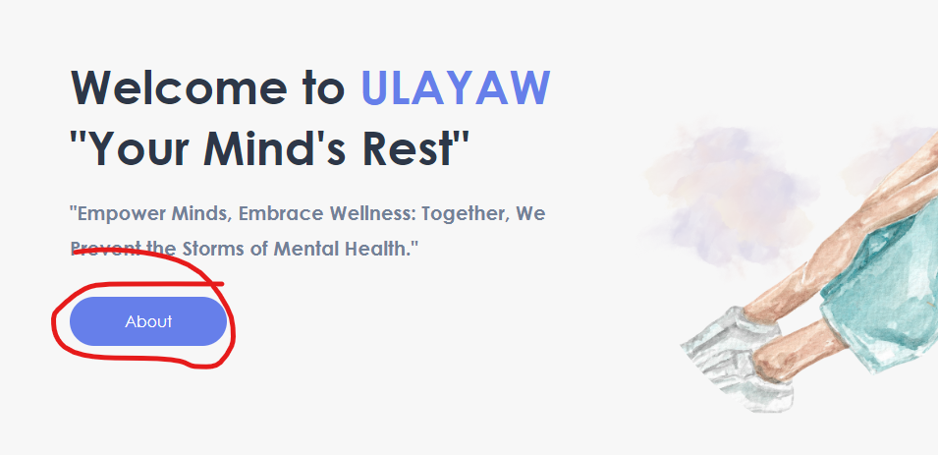

The about page is accessible through this button. This contains information about the developers and the website.

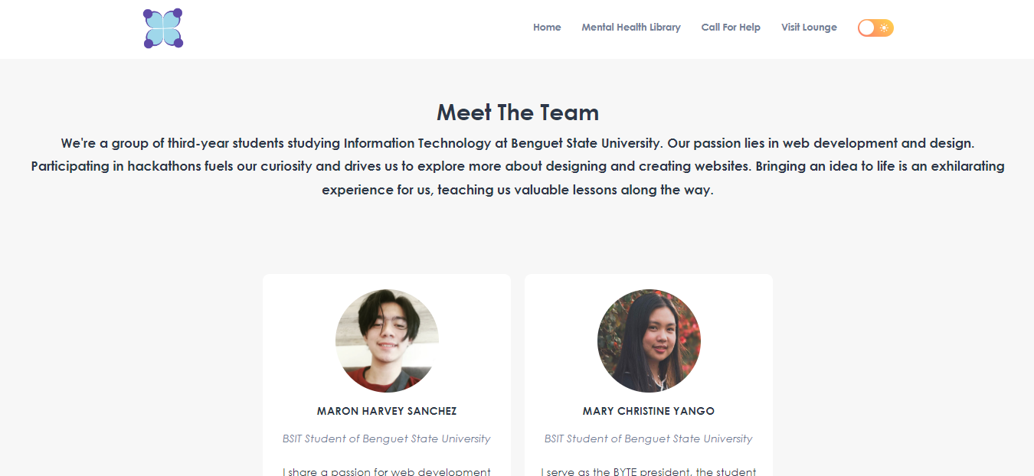

These cards are clickable too! It will redirect you to the social links and portfolio of the developers.



Key Features of the website are in the about page, with links to their respective pages:

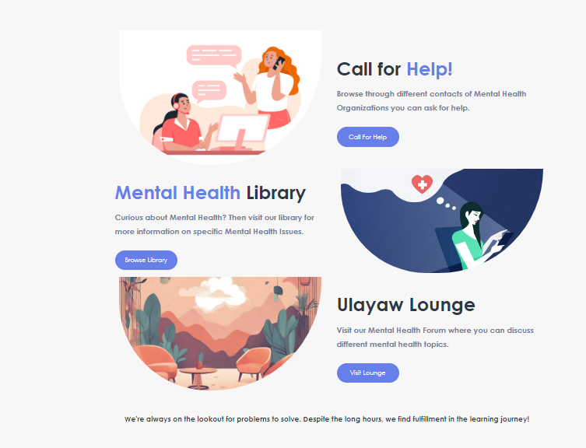

Ulayaw Lounge

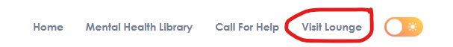The Ulayaw Lounge is accessible through this navbar link, which will open a new tab and redirect you to the login page.

The Ulayaw Lounge is a forum designed for students to talk about certain mental health topics.

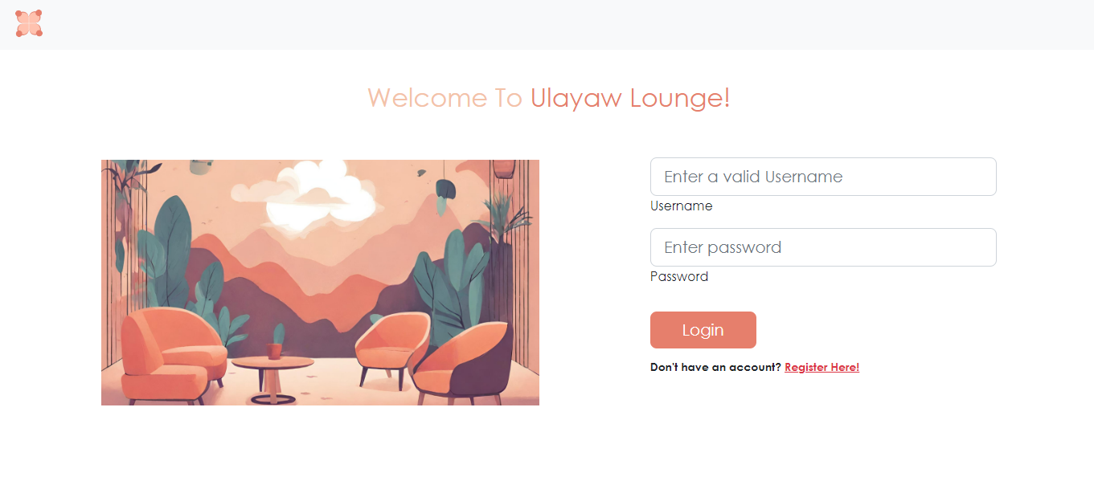User’s can create their own accounts to access the forum.

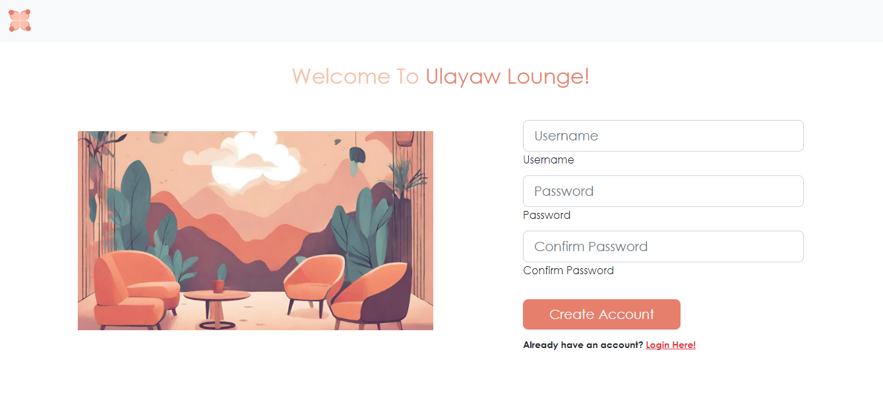

When logged in, the user will be redirected to the homepage of the forum.

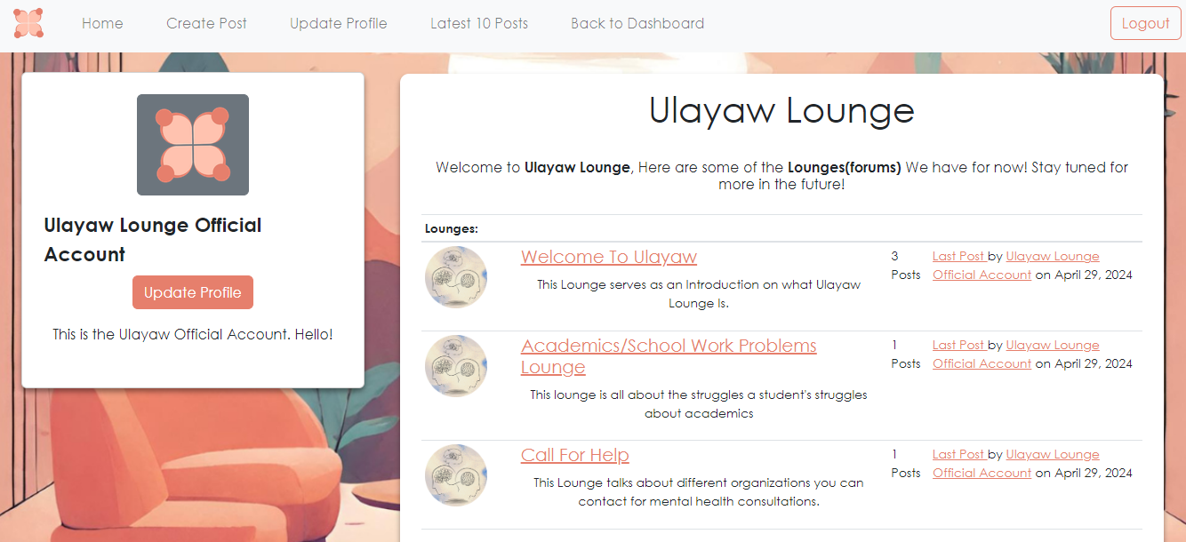

**Ulayaw Lounge (Forums)**

The homepage shows a list of forums available, which was created by the administrator.

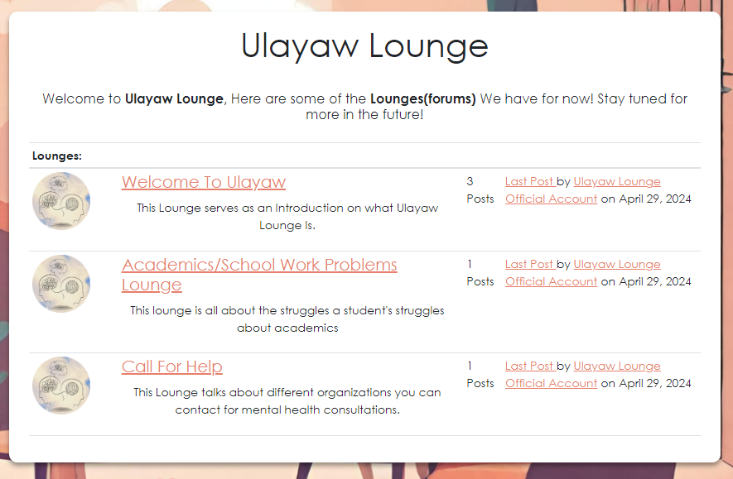

Clicking one of the forum links will take you to the **“Post Page”**, which shows the list of all post inside that forum.

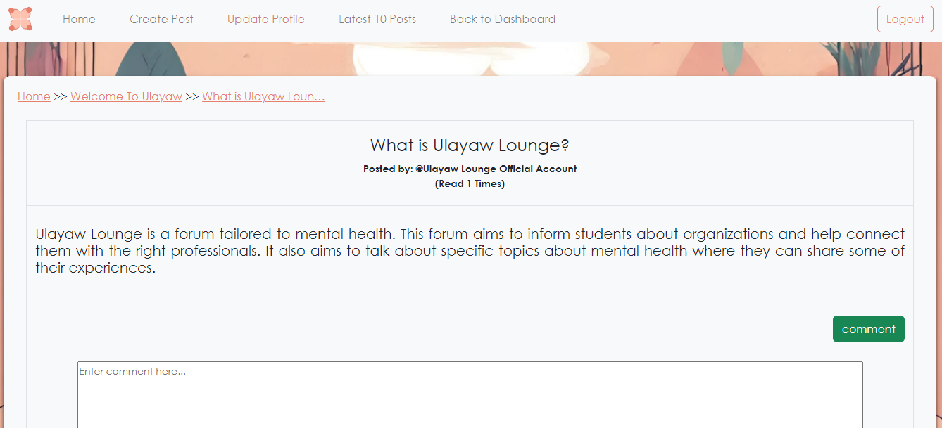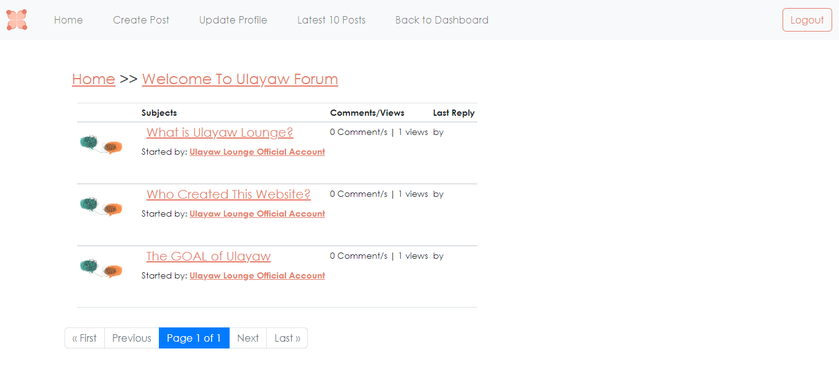

Clicking one of these posts will redirect the user to the contents of the post where users can comment or reply

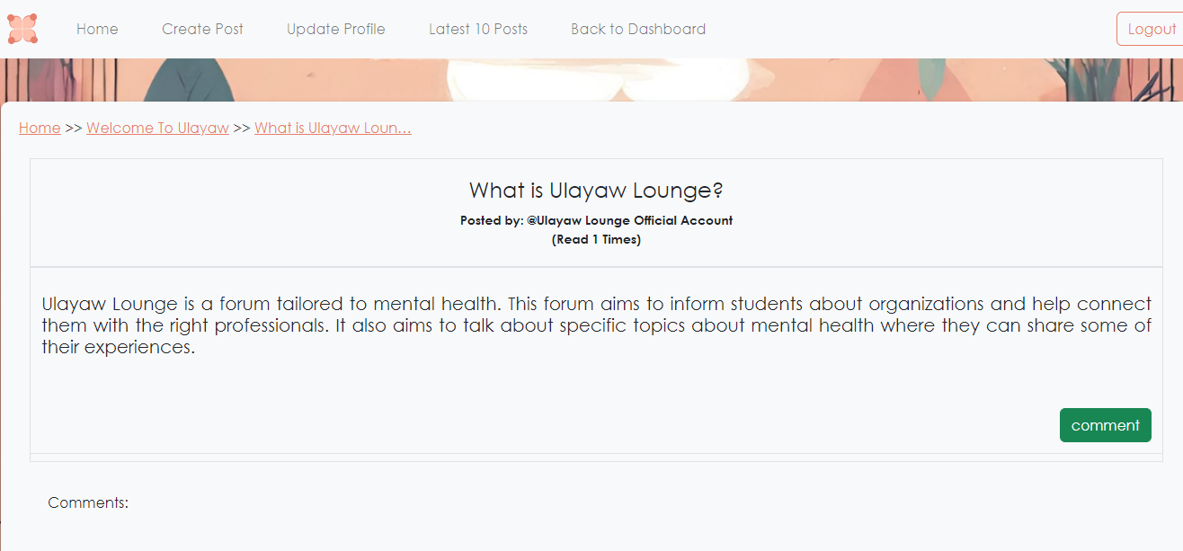

**Update Account Feature:**

By clicking the Update Profile Button in the homepage, or the link in the navbar, the user can edit his/her account. The user will be redirected to a form in which the user can update information, such as Name, Bio, and profile picture.

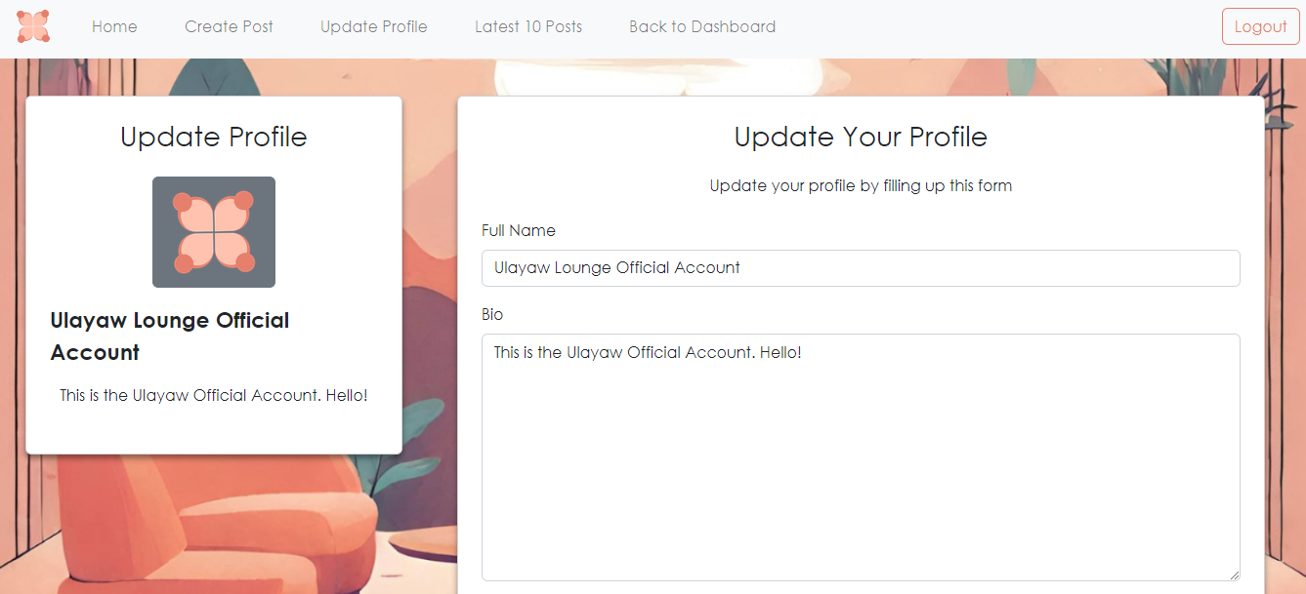

**Create Post Feature:**

Users can create post in different forums, by clicking the “create post” link in the navbar. Users are redirected to a form, where the user has to create a title, content, select which forum he will be posting, and also some tags. **Note:** The administrator will still review the Post before approving it. This will be done in the built-in **django dashboard**.

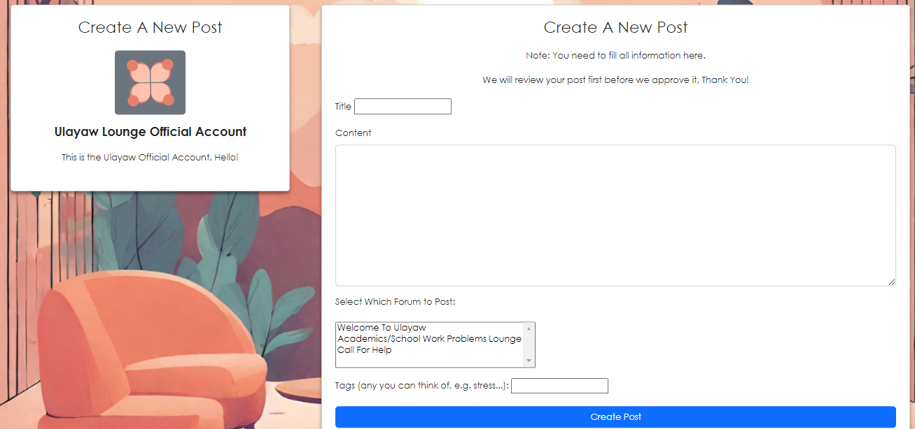

Django has a built-in dashboard, which is only available for the admin (superuser) to access. If the admin logs-in to the Ulayaw Lounge, he is also automatically logged in to the django built-in administrator dashboard. The administrator can manage the post here and he has the ability to approve the post before it is posted on the forums.

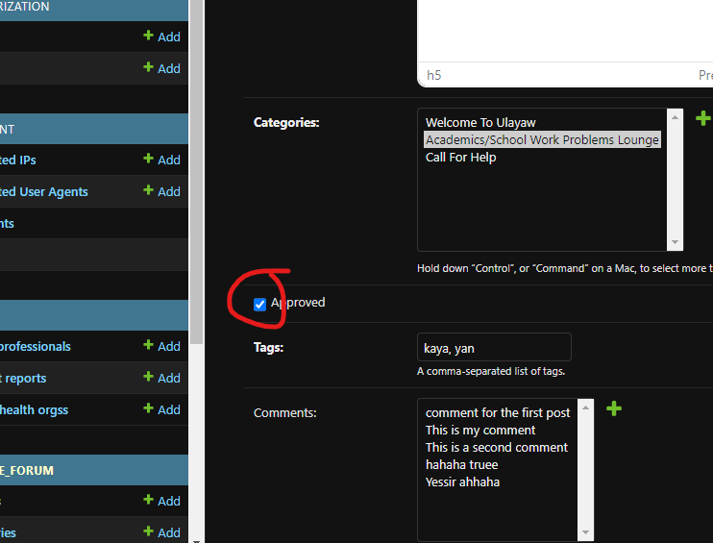

Administrator Login in Ulayaw Lounge

The administrator username is: **admin**

The administrator password is: **UlayawOfficial197524**



When logging in to the lounge with this account, the admin is redirected to the administrator dashboard.

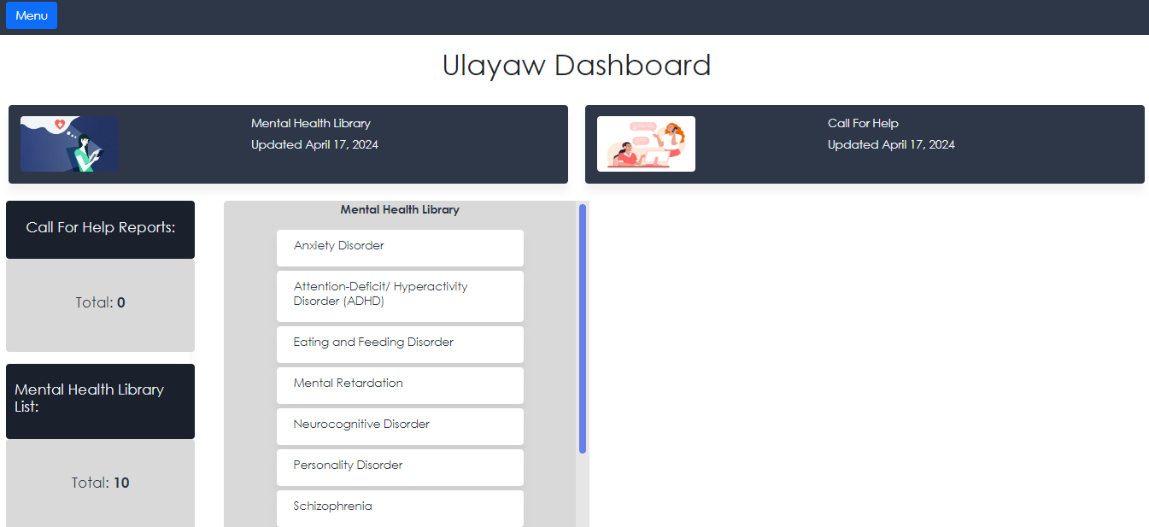

The main dashboard shows the number of incident reports taken from the form from the “Call For Help Page” and the number of mental health blogs in the website.

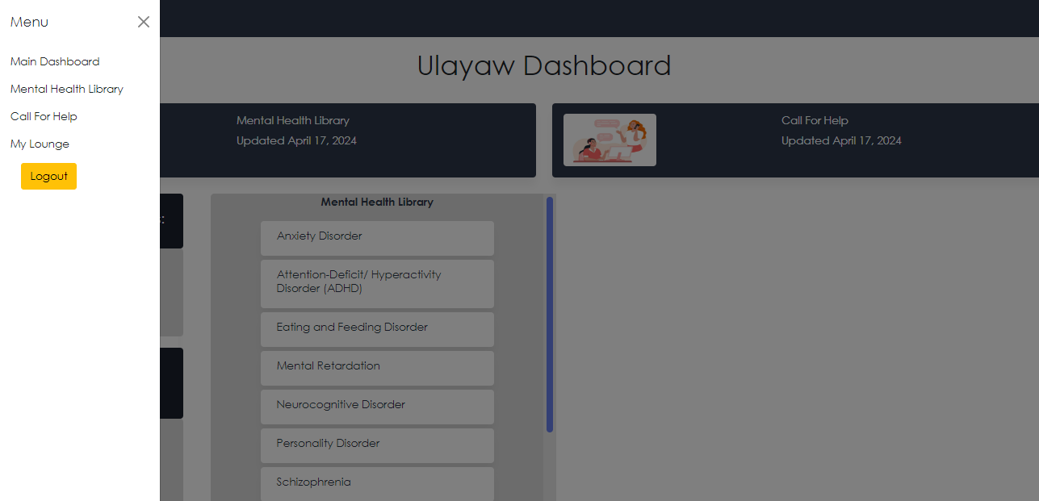

A side panel menu shows some links, let’s start exploring the **Mental Health Library link** from the side panel.

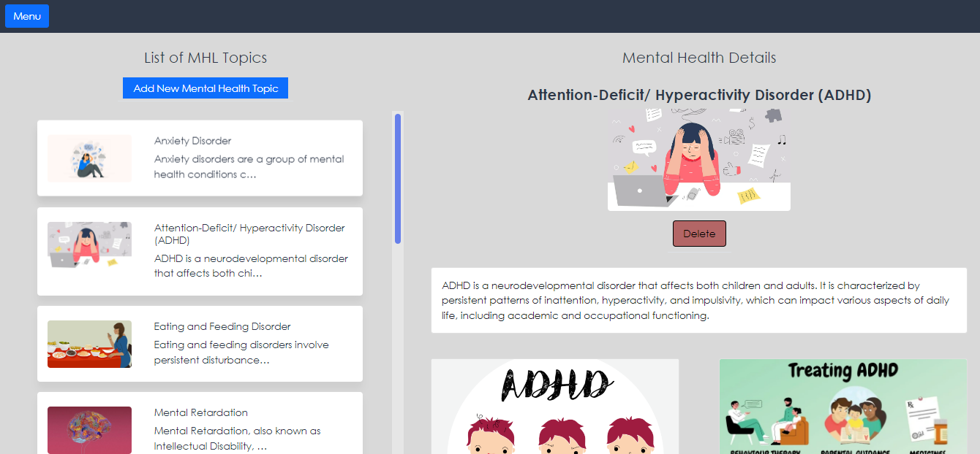

Clicking the link redirects you to a page where the admin can browse and add Mental Health Blogs, which will be reflected in the website. This allows for easier content management.

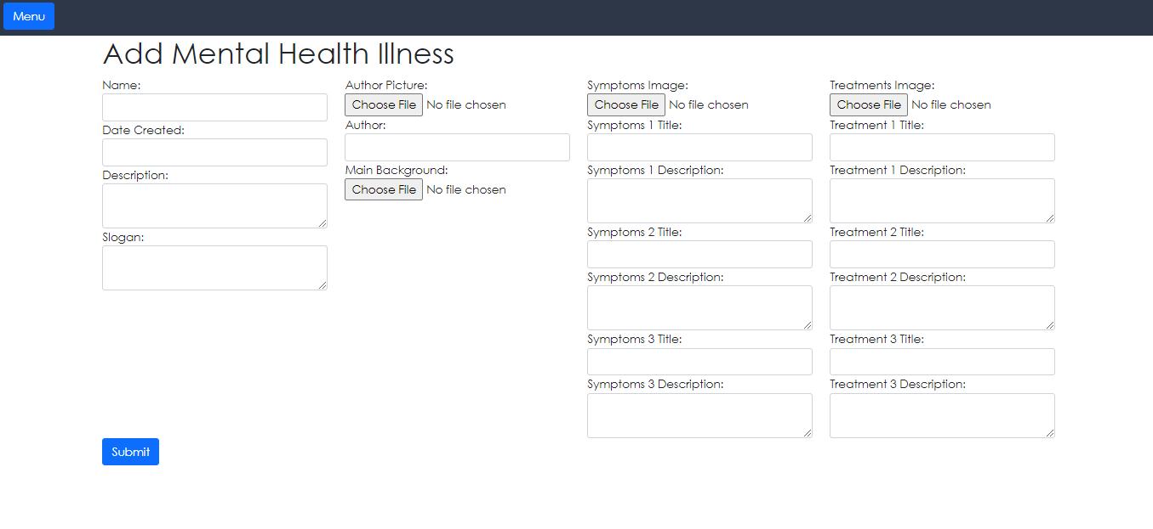Filling this form will add a blog about mental health disorders in the **Mental Health Library.**

Now let’s explore the **Call For Help Link,**

From the form in the **“Call For Help**” Page, the data submitted will be shown in the Call For Help Dashboard

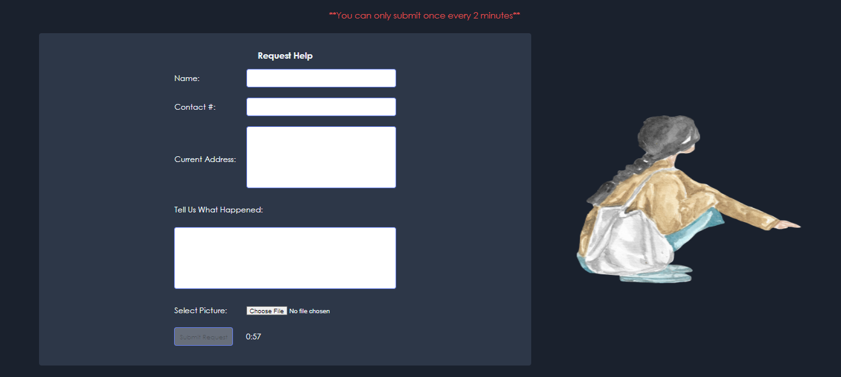

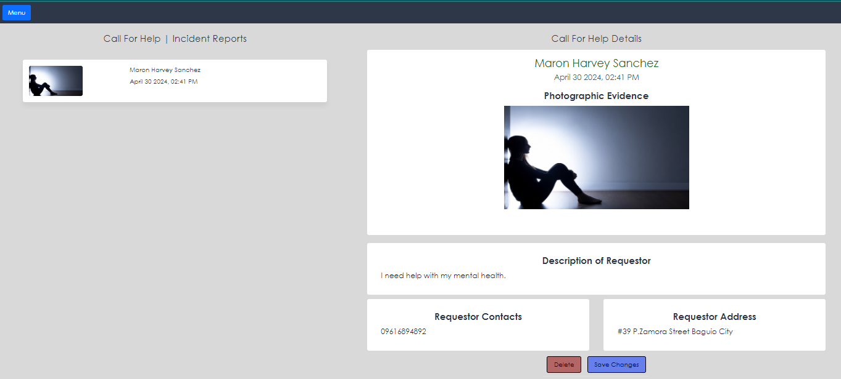

All information submitted by the users will be shown in the dashboard. The administrator is capable of making use of this information to contact the user and connect them with the right people who can help.

Finally, let’s move on to the Ulayaw Lounge:

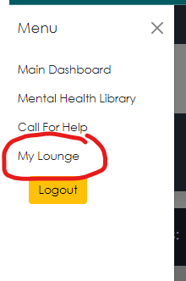

The administrator also has an account on the Ulayaw Lounge.



The administrator serves as the official account for the Ulayaw Lounge.

**Ulayaw User Manual**

Created by: Team BSUians

For APPCON 2023

Link to website:

<https://ulayaw.pythonanywhere.com/>